**Scope of Work**

**Smart Contract**

By



For



|  |  |  |  |
| --- | --- | --- | --- |
| **VERSION HISTORY** | | | |
| **VERSION** | **Prepared by** | **Description** | **Date** |
| V.1.0 | Ritika Nayak | Scope of Work | 22-7-2025 |

**Table of Contents**

1. Project Overview: 2

2) Business Objectives: 3

3) In-Scope: 3

4) Architecture Diagram: 10

5) Project Deliverables: 11

6) Project Timeline: 12

7) Roles and Responsibilities: 13

8) Project Management Approach: 14

9) Quality Assurance and Testing: 14

10)Acceptance Criteria: 14

11) Assumptions and Constraints: 16

12) Change Control 16

13) Legal and Compliance: 17

14) Sign-off: 17

# **1. Project Overview:**

Angel One Broking Ltd identified the need for an automated solution to enhance the efficiency and compliance of its contract notes and regulatory document distribution process. The existing workflow relied heavily on manual intervention for generating PDFs, sending emails, and managing bounce reports — leading to operational bottlenecks, increased turnaround times, and heightened compliance risks.

To address these challenges, the ACC team has proposed the Smart Contract Platform, an end-to-end automation system designed to streamline and secure the complete document lifecycle. This solution will automate the conversion of raw trade data into PDF contract notes, dispatch these documents to clients via email, and provide real-time tracking of delivery, open rates, and bounce statuses.

The primary goal of the initiative is to eliminate manual efforts, ensure regulatory compliance, and improve operational accuracy and visibility across the contract note distribution process.

# **2) Business Objectives:**

* Automate the creation and dispatch of contract notes and other client communication PDFs.
* Eliminate manual processing steps to improve efficiency and reduce errors.
* Ensure real-time tracking of email delivery, bounces, and client engagement.
* Provide access to logs and performance reports for internal audit and compliance purposes.
* Enable a scalable platform that supports multiple document types and segments.

# **3) In-Scope:**

* **Login:**

The new users will be provided with the Email ID and Password to login.

Forgot Password mechanism is provided to the user which is essential to help them regain access to their accounts in case they forget their passwords.

On Clicking on Forgot password, Users will need to enter their Email ID on which they will receive an link to reset their password.

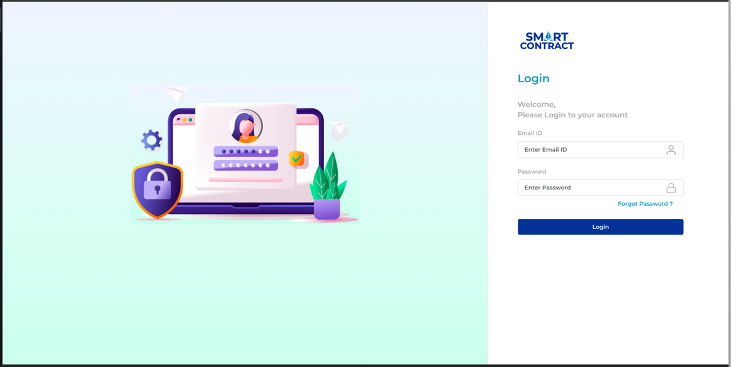

* **Dashboard:**

The Analytical Dashboard enables you to track your email sending at a granular level.

You can track several types of email sending events, including total customer counts, Total Email deliveries, Total Email opens, Total Email clicks, Hard/Soft bounces, Total Email rejections, rendering failures, and delivery delays along with date filter.

Bar graphs, donut charts etc represent the email status count and bounce count for that segment and date. We get the total email sent success count in curved line graph with year filter.

We have the download options for the logs in csv or excel which will provide us the overall view as per the filters selected.

These Key Performing Index empower users to assess the effectiveness of their email campaigns, make data-driven decisions, and optimize their strategies for better future engagement and conversions.

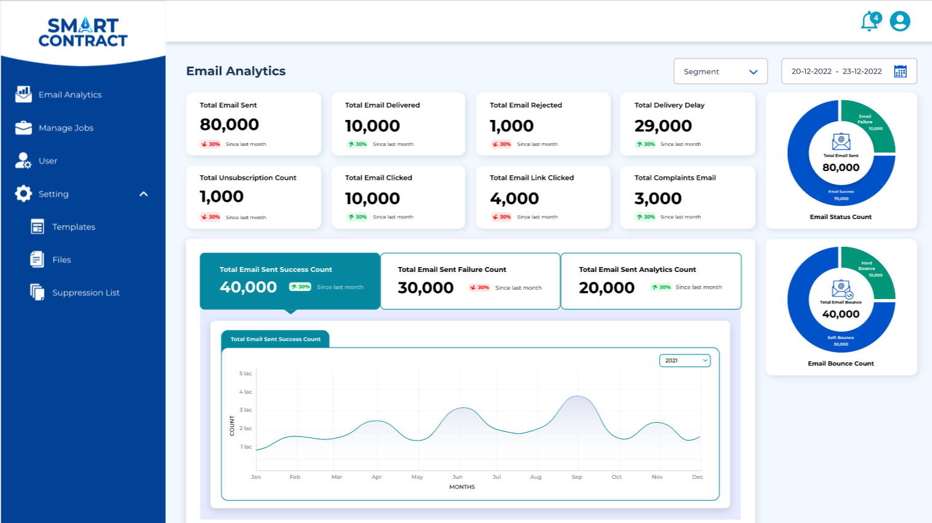

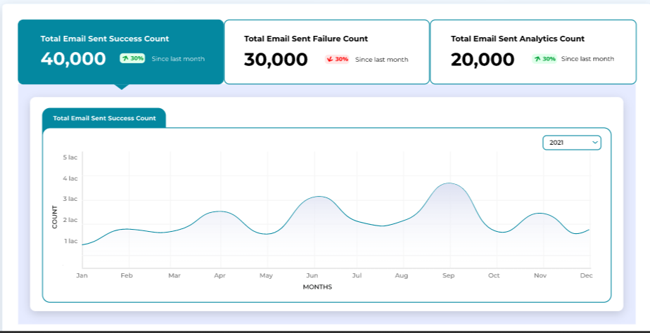

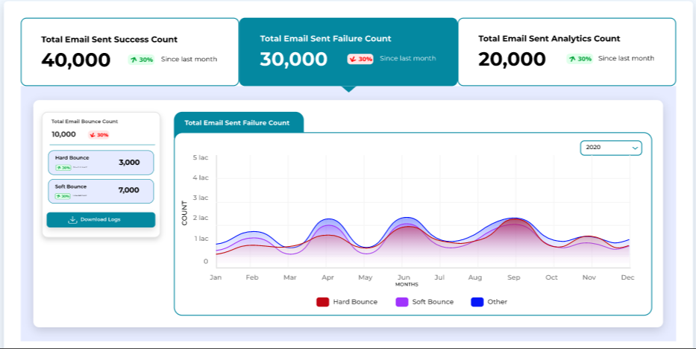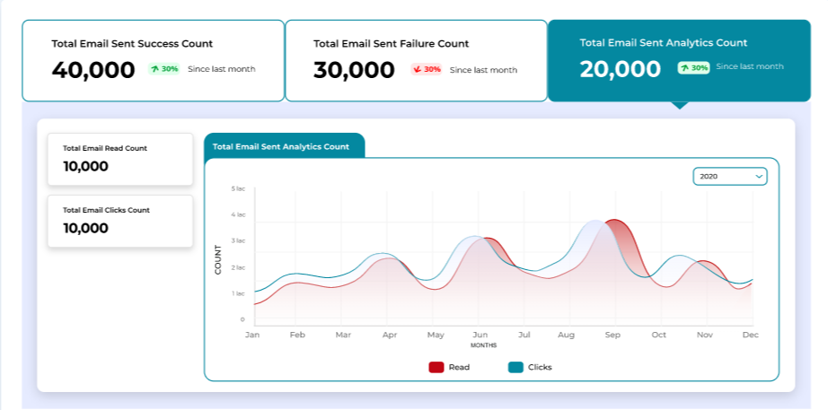

* **Manage Jobs:**

In this section, you can find a comprehensive list of bulk emails that have been processed to the end users. We also get different filters such as segment, status and date range to refine our search criteria.

On clicking on download all the logs of that particular process can be downloaded.

On clicking on a particular ‘job’ you will get the additional details

In the additional detail screen you can perform a search using either the client ID or email address. This search allows you to view and download the log or PDF associated with a specific client.

Additionally, you can filter the results based on various statuses such as sent, hard bounce, soft bounce, delay, etc.

Furthermore, the option to resend a particular email is also available.

After clicking on the upload jobs button, we will be redirected to the above page.

Here we either upload or drag our txt file and select the segment from drop down, for which we are send the email (Ex. Common CN, DMR, PNL) .

The file that we are uploading will contain the customer credentials and other data pertaining to the customer.

Finally, by clicking on send email button and the process of email sending will initiated. Once the process is completed, the emails will be sent to the end customers. It usually takes up to few minutes for the process to complete depending on the customer base.

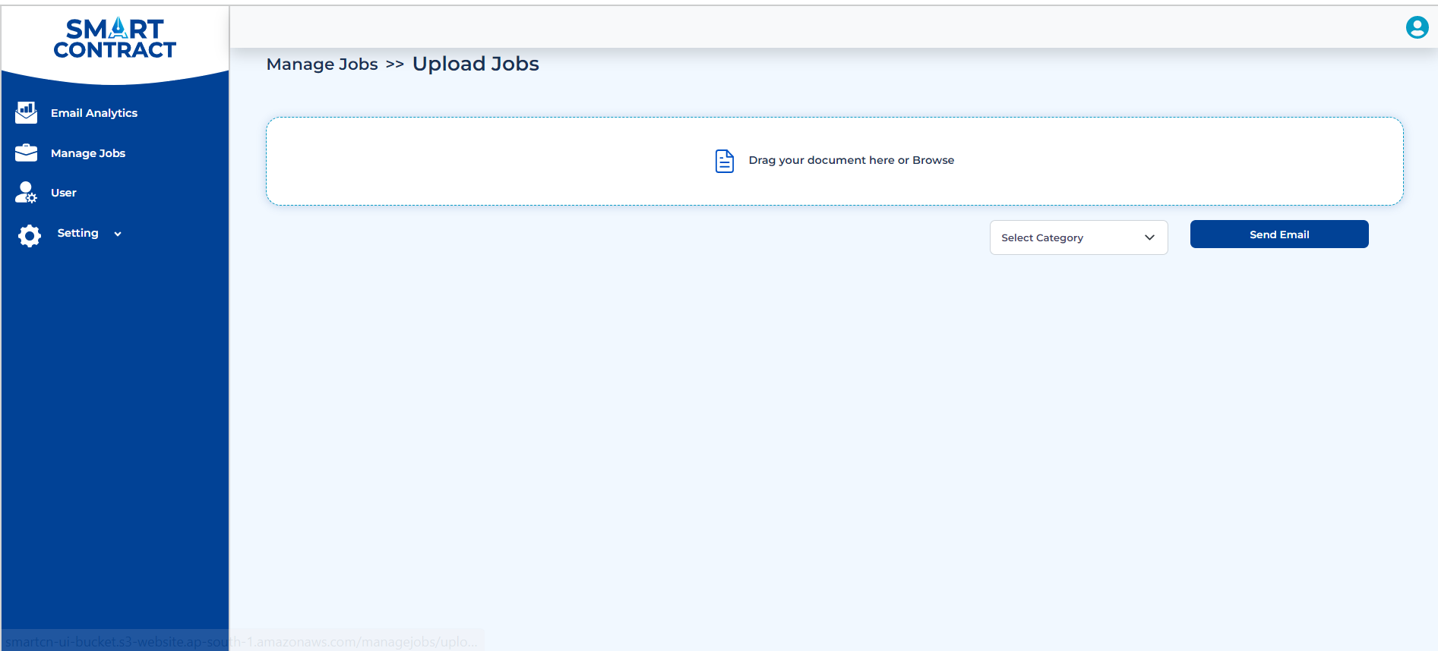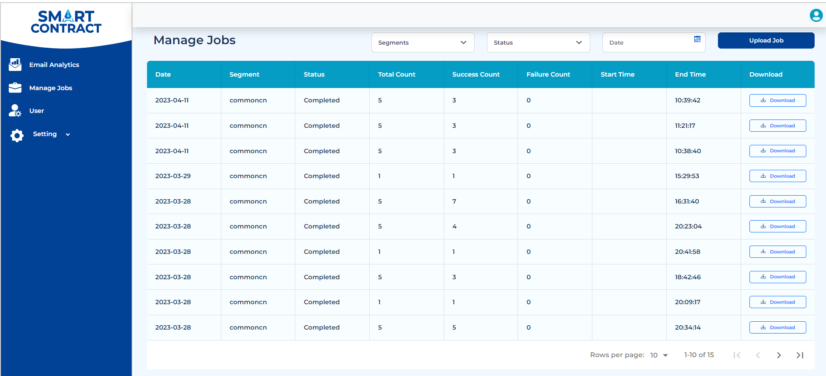

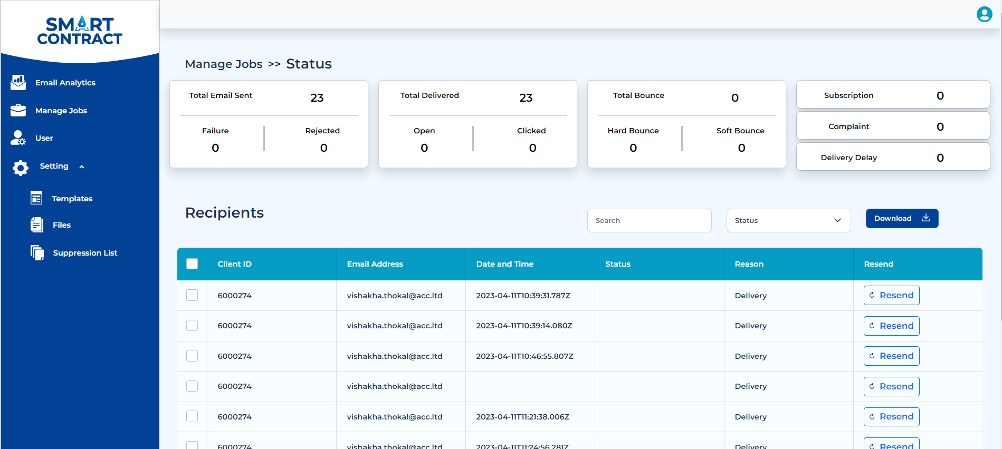

* **Users:**

This section contains the list of all the users that have been created by the admin.

User can be edited or deleted using the options provided in the action column

Admins can create the users can be created using fields such as Name, Email and Password.

Once the user are created and the login credentials are shared with them by the admin.

Users will be able to login successfully using these credentials.

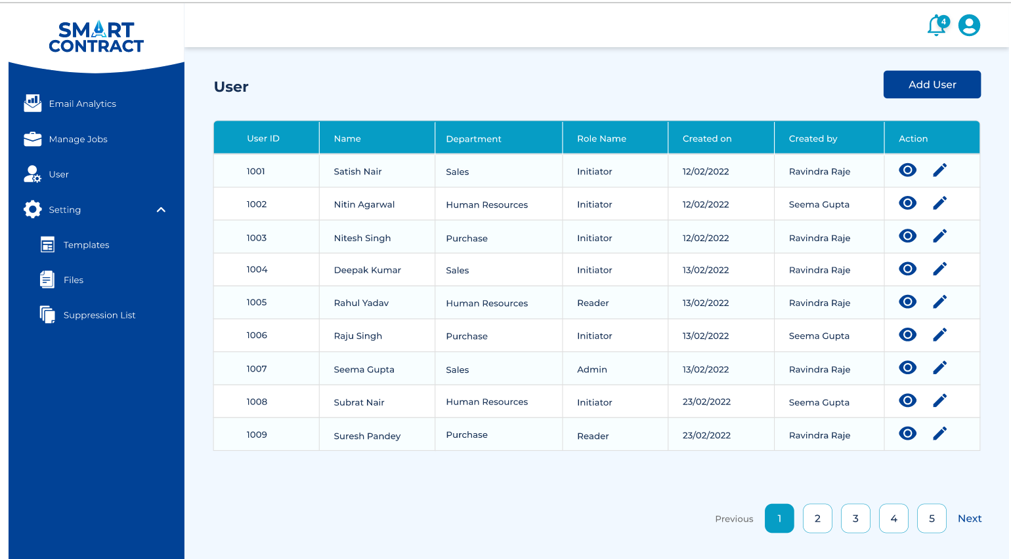

**ACC will be setting up the following module in Angel One’s AWS Account:**

**1.AWS account-(IAM) Access**

AWS Identity and Access Management (IAM) is a web service that helps you securely control access to AWS resources. We use IAM to control who is authenticated (signed in) and authorized (has permissions) to use resources. The access management portion of AWS Identity and Access Management (IAM) helps us define what a principal entity is allowed to do in an account. A principal entity is a person or application that is authenticated using an IAM entity (user or role). Access management is often referred to as authorization. We manage access in AWS by creating policies and attaching them to IAM identities (users, groups of users, or roles) or AWS resources. A policy is an object in AWS that, when associated with an identity or resource, defines their permissions. AWS evaluates these policies when a principal uses an IAM entity (user or role) to make a request. Permissions in the policies determine whether the request is allowed or denied.

**2.AWS S3 - Storage setup**

Amazon Simple Storage Service (Amazon S3) is an object storage service that offers industry-leading scalability, data availability, security, and performance. We use S3 to store the different types of files and the records of all the activity for analytics. Amazon S3 is an object storage service that stores data as objects within buckets. An object is a file and any metadata that describes the file. A bucket is a container for objects. To store data in Amazon S3, we first create a bucket and specify the bucket name and AWS Region. Then, upload our data to that bucket as objects in Amazon S3. Each object has a key (or key name), which is the unique identifier for the object within the bucket. S3 provides features that we can configure to support your specific use case. Buckets and the objects in them are private and can be accessed only if you explicitly grant access permissions. You can use bucket policies, AWS Identity and Access Management (IAM) policies, access control lists (ACLs), and S3 Access Points to manage access.

**3.AWS SES- Email Sending**

Amazon SES is a cloud email service provider that can integrate into any application for bulk email sending. Whether you send transactional or marketing emails, you pay only for what you use. Amazon SES also supports a variety of deployments including dedicated, shared, or owned IP addresses. Reports on sender statistics and a deliverability dashboard help businesses make every email count. We set up domain verification, sender Email verification, and e-mail Analytics settings into customer AWS accounts.

**4.AWS Lambda- Functionality Setup**

AWS Lambda is a serverless, event-driven compute service that lets you run code for virtually any type of application or backend service without provisioning or managing servers. You can trigger Lambda from over 200 AWS services and software as a service (SaaS) application and only pay for what you use. We create microservices according to workflow for design pdf, email template, report generation, dashboard and sending emails.

**5.Design E-Mail templates and PDF templates**

Creating e-mail template and PDF attachment is done according to the customer requirement. We create 6-8 PDF templates in our basic plan.

**6.Report generation and monitoring dashboard**

Report generation methods assist you in keeping track of important measures, such as your account's bounce, complaint and reject rates. Excessively high bounce and complaint rates may jeopardize your ability to send emails using SES. These methods can also be used to measure the rates at which your customers engage with the emails you send by helping you to identify your overall open and click through rates utilizing event publishing and custom domains associated with configuration sets.

# **4) Architecture Diagram:**

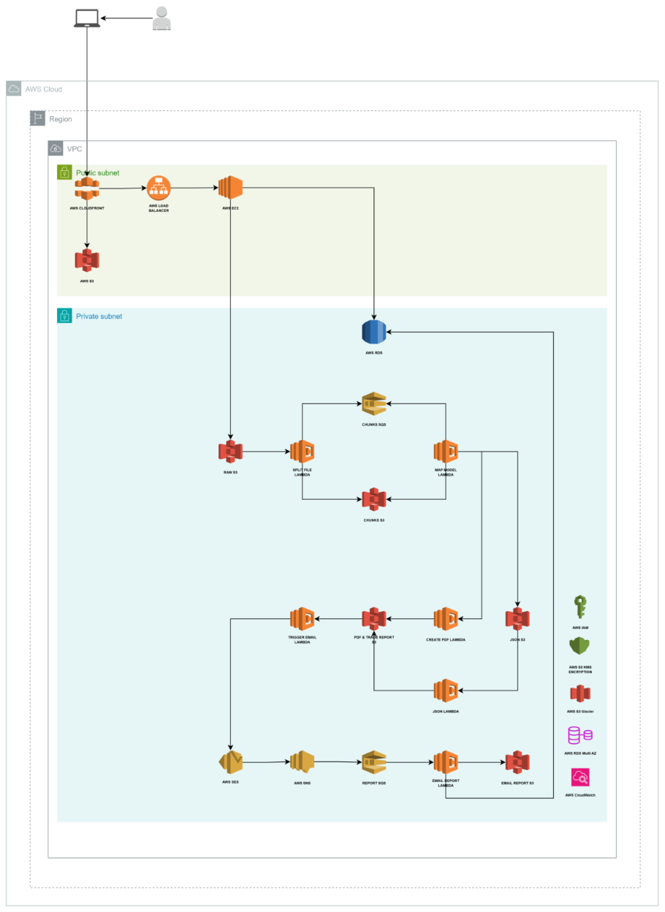

# **5) Project Deliverables:**

1. **Login Module:** A secure login system allows users to authenticate using their credentials. The password recovery feature enables users to reset their passwords through a link sent to their registered email address.

2. **Analytical Dashboard:** A visual dashboard tracks key email performance metrics such as deliveries, opens, clicks, bounces, and delays. Users can filter the data by segment or date and export reports for further analysis.

3. **Manage Jobs:** This module handles bulk email processing and provides search and filtering options for jobs based on segment, status, or date. Users can access detailed logs, view individual email statuses, and resend failed emails.

**4. User Management System:** Admins can create, edit, or delete user accounts through an intuitive interface. This system ensures that user credentials are securely managed and distributed.

**5. Template Management:** Provides functionality for creating, editing, and managing email templates used in campaigns. Templates can be customized for different segments and are stored for easy reuse.

**6. AWS Setup:** Configures AWS IAM for secure access management, S3 for file storage, SES for bulk email sending, and Lambda for automated workflows like email sending, PDF generation, and report creation.

**7. PDF and Email Templates:** Six to eight customization email and PDF templates are designed based on client requirements. These templates will be used for automated email campaigns and reporting.

# **6) Project Timeline:**

|  |  |  |
| --- | --- | --- |
| **Phase** | **Task Description** | **Estimate Time** |
| Requirement Gathering | 1. Project Kick-off & Document creation.  2. Escalation points, Communication plan, Risks and issue reporting mechanism. Access to operational source systems of the data and sample data encryption & compliance needs.  3. Design & Architecture definition and Walk-through | 1-2 Weeks |
| Development | 1. Initial setup of AWS IAM, S3, SES, and Lambda as per requirement.  2. Development of Login, User Management, and File Management modules.  3. Implementation of Analytical Dashboard and Manage Jobs functionalities.  4. Development of Template Management, Suppression List, and Report Generation modules. | 6 Weeks |
| QA | 1. Testing Documentations  2. Testing, debugging, and UAT.  3. Bug Fixing | 2 Weeks |
| Go Live | Go-live and post-launch support. | 1 Week |

# **7) Roles and Responsibilities:**

·1) Client:

* Provide all necessary data, requirements, and access to the AWS environment.
* Participate in UAT and provide timely feedback on deliverables.

2) Project **Team**:

* **Project Manager**: Oversee the project, ensuring timely delivery and client communication.
* **AWS Architect**: Responsible for setting up IAM, S3, SES, and Lambda.
* **Development Team**: Create modules, dashboards, and workflows.
* **QA Team**: Ensure the product meets quality standards through testing.

·3) **Third-party Vendors**:

* AWS as the cloud service provider.

# **8) Project Management Approach:**

* BRD/FSD will be created by ACC and Client will provide sing off on it
* ACC will follow agile methodology
* Client team will provide SPOC from their side
* Product owner will help with the product backlogs
* BA/Scrum master from ACC will create project management board and create Epic, user stories with mockups
* 1 week on sprint will be followed with incremental deliveries
* Product backlogs refinement, sprint planning, daily stand up, sprint review, delivery and sprint retrospection events will be followed
* New requests will be parked at backlogs and will be discussed during product refinement session.

# **9) Quality Assurance and Testing:**

Developers will cover unit testing before creating build and QA team will first focus on DOD set for entire sprints. Test cases templates will be provided to Axis team for format sign off and based on same templates QA team will create test cases of each delivered increment.

# **10)Acceptance Criteria:**

**Login Module:**

* Users must be able to log in using provided credentials.
* The "Forgot Password" function must send a reset email to the registered address and allow the user to change their password.
* Login credentials and password recovery links must be securely encrypted and comply with industry-standard security protocols.
* **Acceptance**: Successful completion of UAT with no critical security or usability issues.

**Analytical Dashboard:**

* The dashboard must display key email metrics such as total deliveries, opens, clicks, bounces, and delays.
* Filters by segment and date range must function correctly.
* All data exports (CSV, Excel) must reflect the selected filters.
* **Acceptance**: Metrics displayed correctly, filters work as expected, and data export functionality is validated in UAT.

**Manage Jobs:**

* The list of bulk email jobs must display correctly with the ability to filter by status and date.
* Detailed logs for individual jobs must be retrievable by client ID or email.
* Emails must be successfully resent for jobs marked as failed.
* **Acceptance**: Logs are complete and downloadable, and the resend function works as expected.

**User Management:**

* Admins must be able to create, edit, and delete user accounts without errors.
* Users must receive their credentials and be able to log in using the provided details.
* **Acceptance**: Admin functions verified in UAT, and user login process is validated.

**File Management:**

* Files must be uploaded, stored in S3, and retrievable.
* S3 bucket permissions must restrict unauthorized access.
* **Acceptance**: File upload and access are verified, with appropriate permissions confirmed.

**AWS Integration:**

* IAM, S3, SES, and Lambda must be correctly set up and integrated with the platform.
* Email sending and Lambda-triggered workflows must function as expected.
* **Acceptance**: AWS services are validated during UAT, ensuring email sending, storage, and Lambda functions work correctly.

**Template and PDF Design:**

* Templates must match the client-provided specifications.
* PDFs must be properly formatted and attachable to emails.
* **Acceptance**: UAT verifies that templates and PDFs are correctly designed and functional.

**Report Generation and Monitoring Dashboard:**

* Reports must display accurate metrics for bounce rates, open rates, and complaints.
* Custom filters and data exports must work correctly.
* **Acceptance**: Reports are tested for accuracy and functionality during UAT.

**General Acceptance Criteria for All Deliverable**:

* No critical bugs or errors remain unresolved.
* All functionality must pass UAT, with feedback from the client incorporated.
* Written acceptance from the client after UAT is mandatory for each milestone or module.

# **11) Assumptions and Constraints:**

Client Collaboration: We anticipate receiving dedicated or partial support from the client for any dependencies identified during project execution.

Scope of Work: The project scope has been defined. Any additional work outside of this scope will be contracted separately on an effort basis.

Deliverable: All materials created as part of this project will be transferred to the client team upon completion.

Cost Allocation: Travel expenses (if applicable) will be billed to the client at cost. Other Direct Costs (ODCs) will be invoiced at cost plus administrative overhead.

# **12) Change Control**

For any changes the Client team will raise change request form. Change request form will be validated by ACC. Impacted/increased timeline due to change request project commercials will be impacted. New requests will be parked at backlogs and will be discussed during product refinement session

# **13) Legal and Compliance:**

**Email Compliance:** The system should automatically handle unsubscribe requests, ensuring compliance with email regulations such as CAN-SPAM. Users should also be notified if they attempt to email contacts that are on the suppression list.

**Data Localization:** Depending on regional requirements, the system must ensure that data is stored in specific geographic locations (e.g., within the EU for GDPR compliance) and handle cross-border data transfers securely, adhering to legal guidelines.

# **14) Sign-off:**

|  |  |
| --- | --- |
| **Customer sign off** |  |
|  |  |
| I, (the Customer), am confirming that this document has all the requirements as per our expectations |  |
|  |
|  |
| X__________________________________   DocuSign, electronic signature – refer [https://www.digisigner.com/free-electronic-signature/sign-document-online](https://www.digisigner.com/free-electronic-signature/sign-document-online" \t "https://inc-word-edit.officeapps.live.com/we/_blank) |  |